 Habib University
EE-437 Renewable energy systems – Fall 2025

Time = 20 minutes | Quiz 01 CLO 1 (Cog-2) | Max Points: 20
Question 1 [2 points]: Differentiate between Primary energy and final energy and give an example of each.
Question 2 [2 points]: A solar power plant with 1500kW installed capacity produces 1.1GWh in a single year. What is its capacity factor?
Question 3 [2 points]: Draw the Carnot cycle and Rankine cycle on the graph below:
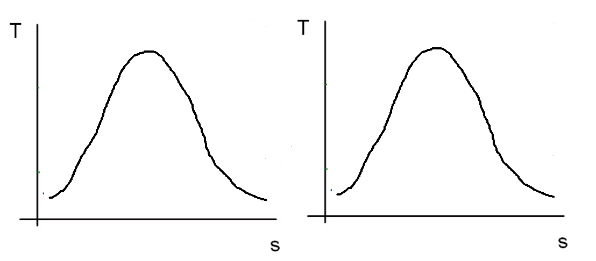
Question 4 [2 points]: A power plant claims to be 90% efficient. What must be the minimum value of T_H to achieve this efficiency considering T_C to be 27°C?
Question 5 [2 points]: What is the formula for efficiency of a combined cycle plant if n1 is efficiency of gas turbine and n2 is efficiency of steam cycle.
Question 6 [1 point]: Between coal, oil and gas, which has the highest energy density?
Question 7 [1 point]: Modify the Carnot efficiency formula so that T_H and T_C are in Celsius instead of Kelvin.
Question 8 [2 point]: Give any 2 differences between a gas turbine powerplant and a coal power plant.
Question 9 [6 points]: A coal power plant with rated capacity of 500MW with capex at $2,500/kW is expected to last for 20 years. Its fixed O&M is $40/kW per year, and fuel cost is $25/MWh. Its capacity is 85%. Calculate its LCOE in terms of $/kWh (Hint: The denominator will be total energy produced).

